Raihanata Barry
American University
EDU 636: Education Policy and Research Methods
Professor Jennifer Steele
April 27, 2026

Abstract
This study compares education funding and inclusion policies across OECD and non-OECD countries to examine how they shape access to inclusive education for students with disabilities. Using secondary data from OECD, UNESCO, World Bank, and national sources, it analyzes eight countries: the United States, Finland, Germany, South Korea, South Africa, Kenya, Brazil, and India. A comparative policy analysis explores links between per-student funding, system structure (tracking and segregation), and inclusion outcomes.
Findings show that higher spending alone does not guarantee more equitable inclusion. Countries with more equal funding distribution and early intervention systems, such as Finland, show stronger and more consistent inclusion. In contrast, decentralized or divided systems like the United States, Germany, and South Korea show more uneven outcomes. Non-OECD countries face additional barriers such as lower funding, limited infrastructure, and reliance on NGOs and special education units, which widen the gap between inclusive education policy and actual practice.

Introduction
Inclusive education is a policy and instructional approach that places all students regardless of disability, background, or learning differences in the same classrooms while requiring schools to adapt instruction and support systems to ensure equal access to curriculum. It focuses on removing barriers through differentiated instruction, accommodations, and universal design, shifting responsibility from the student to the education system. Globally, it is important because it promotes equity, reduces segregation and stigma, strengthens social cohesion, and supports long-term economic development by improving outcomes and reducing inequality in line with Sustainable Development Goal 4.
Literature Review

OECD countries refer to member states of the Organisation for Economic Co-operation and Development, typically high-income nations with established education systems and standardized data reporting structures. Non-OECD countries refer to nations outside this membership, often characterized by lower average income levels, more variable education infrastructure, and less standardized data systems.
Organisation for Economic Co-operation and Development Countries (United States, Finland, Germany, South Korea)
This section examines inclusive education across selected OECD countries using comparative OECD data to analyze how funding levels, legal frameworks, and system design shape access for students with disabilities. Although all four countries formally commit to inclusive education, OECD evidence highlights substantial variation in implementation and equity outcomes.
In the United States, inclusive education is governed by the Individuals with Disabilities Education Act (IDEA), which guarantees access to services in the least restrictive environment. Despite relatively high spending at approximately USD 20,387 per student, OECD data highlight significant within-country inequalities driven by decentralized state and local funding structures. These disparities result in uneven access to specialized staff, services, and individualized education plans across districts (OECD, 2023; OECD, 2025).
Finland is consistently identified as one of the strongest inclusive education systems in the OECD. Its model emphasizes early intervention and sustained support within mainstream classrooms rather than segregation. OECD research notes that “support is provided early and flexibly within mainstream education rather than through separate special education pathways” (OECD, 2023). Because funding is more equitably distributed across municipalities and early tracking is limited, Finland demonstrates higher equity and more consistent inclusion outcomes.
Germany operates a dual-track system in which mainstream schools exist alongside special schools (Sonderschulen). OECD research describes a “strong tradition of early selection,” which continues to shape student placement within the system (OECD, 2023). Despite relatively high spending (USD 15,000–16,500 per student), structural separation limits full inclusion, with students with disabilities more likely to experience segregated or partially segregated learning environments.
South Korea represents a transitional inclusion model. While inclusive education policies have expanded, the system continues to rely heavily on special education institutions alongside mainstream schooling. With spending of approximately USD 16,000–17,500 per student, resources remain largely concentrated in specialized settings rather than fully integrated classrooms. OECD research further notes that inclusive education “coexists with specialized institutions,” resulting in many students experiencing partial rather than full inclusion (OECD, 2023).
Overall, across OECD countries, the literature indicates that higher spending alone does not guarantee equitable inclusion. Systems with more equitable funding distribution and reduced tracking, such as Finland, demonstrate stronger and more consistent inclusion outcomes, while decentralized or structurally divided systems such as the United States, Germany, and South Korea show greater variation in access and educational experience.
Non-Organisation for Economic Co-operation and Development Countries (South Africa, Kenya, Brazil, India)
This section examines inclusive education in South Africa, Kenya, Brazil, and India, focusing on how structural and resource constraints shape access for students with disabilities. Compared to OECD countries, these systems operate with lower education funding and greater reliance on NGOs, donor assistance, and external support, contributing to uneven service delivery.
Although inclusive education policies exist across all four countries, implementation is constrained by infrastructure deficits, shortages of trained personnel, overcrowded classrooms, and unequal urban–rural resource distribution. As a result, a persistent gap remains between policy and practice, leading to unequal educational outcomes for learners with disabilities.
In South Africa, inclusive education is guided by Education White Paper 6; however, implementation remains uneven due to structural and resource constraints (UNESCO, 2020; World Bank, 2024). With spending of approximately USD 4,000–6,000 per student, many rural schools face staffing and infrastructure shortages and often rely on NGOs and special schools for additional support.
Kenya faces similar challenges. Although inclusive education policies are in place, implementation remains limited due to low funding levels (USD 2,000–4,000 per student) and weak infrastructure (OECD, 2025). Schools frequently experience overcrowding, accessibility barriers, and limited trained staff, resulting in reliance on donor-supported programs and special education units.
Brazil has a strong legal framework for inclusive education, but implementation varies significantly across regions. Despite spending approximately USD 4,000–6,000 per student, persistent inequalities between urban and rural areas create infrastructure gaps (OECD, 2025). NGOs and community-based programs frequently supplement services, while special education institutions remain essential in under-resourced areas (UNESCO, 2020; World Bank, 2024).
India maintains strong legal protections for inclusive education under the Right to Education Act (2009) and the Rights of Persons with Disabilities Act (2016). However, implementation remains uneven due to system scale and regional disparities. With spending of approximately USD 1,500–3,500 per student, schools often face overcrowding, limited accessibility, and shortages of trained staff, leading to reliance on resource rooms, NGOs, and special schools.
Overall, while all four countries demonstrate strong policy commitments to inclusive education, implementation remains constrained by funding limitations, infrastructure challenges, and unequal access to educational resources.

Synthesis
Overall, the literature makes it clear that inclusive education is widely recognized as a global policy goal, but there is still a consistent gap between policy and real-world implementation across both OECD and non-OECD countries. While most systems aim to improve access for students with disabilities, actual outcomes depend heavily on how education systems are funded, structured, and supported in practice.

Looking at OECD countries, stronger funding systems and legal frameworks generally support more developed inclusion models, but outcomes still vary. Finland shows more consistent inclusion due to equitable funding, early intervention, and minimal tracking. In contrast, the United States, Germany, and South Korea show more uneven results because of decentralized funding and continued reliance on segregated or specialized education systems.

Shifting to non-OECD countries, inclusive education policies are also in place in countries like South Africa, Kenya, Brazil, and India, but implementation is more limited. Lower funding levels, infrastructure challenges, and shortages of trained staff often lead to reliance on NGOs and external support, which creates uneven access across regions.

Taken together, the literature shows that inclusion outcomes are shaped less by policy intent and more by how resources and systems are implemented, reinforcing the need for stronger cross-national comparisons of equity in practice.
Research question
How do differences in special education funding between OECD and non-OECD countries relate to the inclusion of students with disabilities in mainstream classrooms? This study asks how differences in special education funding between OECD and non-OECD countries relate to the inclusion of students with disabilities in mainstream classrooms. It builds on existing literature showing that while inclusive education is widely supported in policy, there remains a consistent gap between policy and implementation, with outcomes varying based on funding levels, system structure, and access to support services. The study extends this research by comparing per-student funding and inclusion rates across OECD and non-OECD systems, focusing on how structural and financial conditions shape actual classroom inclusion rather than policy intent alone. Based on prior research, it is expected that higher funding will generally be associated with greater inclusion; however, this relationship is likely to vary depending on system design, including tracking practices, resource distribution, and availability of support services. Overall, funding is expected to be an important but not sufficient factor in explaining inclusion outcomes.
Setting and Intervention
This study uses a quantitative cross-national comparative design based on secondary data, examining inclusive education systems across eight countries: the United States, Finland, Germany, and South Korea (OECD), and South Africa, Kenya, Brazil, and India (non-OECD), selected for variation in funding levels, policy structures, and inclusion approaches. The analysis is conducted at the national education system level, focusing on the relationship between special education funding and inclusion in mainstream classrooms, while identifying broader patterns in outcomes across countries. This approach allows for systematic comparison across multiple systems and helps reveal global patterns in how funding and policy shape access for students with disabilities.
Data Sources and Sample Size
This study uses secondary quantitative data drawn from international education databases, including OECD Education at a Glance, UNESCO Institute for Statistics, and World Bank education indicators. The sample includes eight countries: four OECD countries (United States, Finland, Germany, and South Korea) and four non-OECD countries (South Africa, Kenya, Brazil, and India). These countries were selected to capture variation in income level, education funding structures, and inclusive education policy implementation.
The main independent variable is per-student education funding, measured in USD, while the primary dependent variable is the inclusion rate of students with disabilities in mainstream classrooms. Inclusion is operationalized using national and international reporting on the percentage of students with disabilities educated in general education settings. Additional contextual variables include national policy framework strength, system structure (inclusive vs. dual-track systems), and reliance on special education institutions or external support systems.
Because this is a comparative policy analysis, the study does not rely on a treatment or experimental design. Instead, it uses cross-national descriptive statistics to examine patterns between funding levels and inclusion outcomes. Data were compiled and standardized across sources to ensure comparability across countries with different reporting systems.
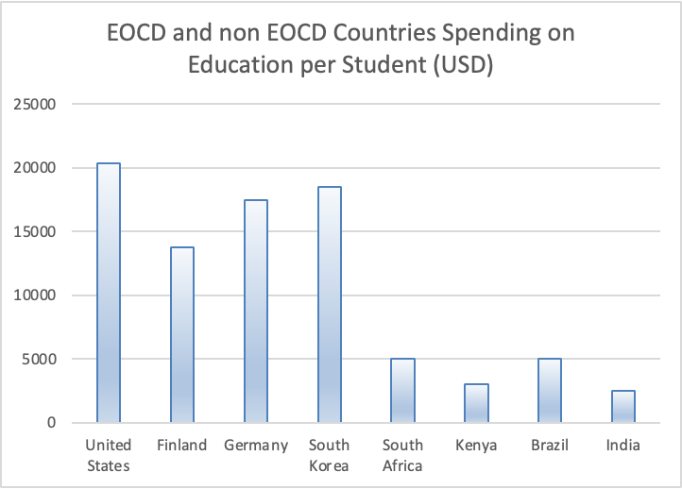
Table 1 summarizes the descriptive characteristics of the sample, including key demographic and educational indicators where available.

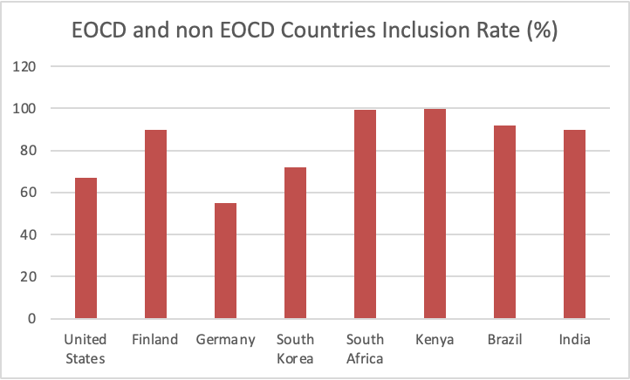
Table 2 presents the distribution of inclusion rates across countries, disaggregated by grade level where data were available.
Overall, the analytic sample allows for a structured comparison of how funding levels and system design relate to inclusive education outcomes across both OECD and non-OECD contexts, with a focus on identifying consistent global patterns rather than causal effects.
Findings
The findings show that higher education funding does not automatically lead to stronger inclusive education outcomes for students with disabilities. OECD countries spend significantly more per student, with the United States at about $20,387, followed by South Korea, Germany, and Finland. Non-OECD countries such as South Africa, Brazil, Kenya, and India generally spend between $2,500 and $5,000 per student.
However, higher spending does not consistently translate into higher inclusion rates. Finland demonstrates one of the strongest outcomes, with about 90% of students with disabilities in mainstream classrooms, despite spending less than the United States. This suggests that equitable funding distribution, early intervention, and reduced tracking may matter more than total spending.
In contrast, the United States shows that although 67% of students with disabilities spend most of their day in general education classrooms, access varies widely across districts due to decentralized funding systems. Germany and South Korea follow similar patterns, where relatively high spending is paired with lower inclusion due to tracking systems, special schools, and separate classroom structures.
In non-OECD countries, South Africa and Kenya report very high mainstream enrollment rates, but this does not always reflect full inclusion because many schools lack trained staff, resources, and support services. Brazil and India show similar patterns, where strong legal frameworks exist but implementation is uneven and often supported by NGOs.
Overall, the strongest pattern across countries is that inclusion depends more on how funding is structured and used than on how much is spent. Systems with stronger support structures and less segregation show more consistent inclusion outcomes than higher-spending but fragmented systems.
Analytical Method
This study uses a comparative quantitative research design to examine the relationship between education funding and inclusive education outcomes across OECD and non-OECD countries. Secondary data were collected from OECD Education at a Glance reports, UNESCO Global Education Monitoring reports, World Bank education datasets, NCES IDEA reports, and national education ministry publications. The sample includes eight countries: the United States, Finland, Germany, South Korea, South Africa, Kenya, Brazil, and India.
The independent variable in this study is education spending per student, measured in approximate PPP-adjusted U.S. dollars. The dependent variable is the inclusion rate of students with disabilities in mainstream schools or general education classrooms. Additional system-level factors such as legal frameworks, early tracking, and reliance on special schools were also used to interpret differences in inclusion outcomes across countries.
Using Excel, I organized the data into comparative tables and calculated descriptive statistics to identify patterns between funding levels and inclusion rates. I then created two visual comparisons: a bar graph showing education spending per student across countries and a second bar graph showing inclusion rates of students with disabilities in mainstream settings. These figures were used to compare OECD and non-OECD systems and examine whether higher funding levels were associated with stronger inclusive education outcomes. The analysis focused on identifying cross-national patterns rather than establishing direct causation.

Gap in research
There is still a limited body of cross-national research that systematically examines how inclusive education functions in practice for students with disabilities. Most existing studies focus on individual countries or broad policy frameworks rather than directly comparing equity outcomes across different education systems.

As a result, there remains a gap in global, equity-focused research that clearly distinguishes between inclusive education as a policy commitment and its actual implementation in classrooms, particularly in terms of placement, access to services, and instructional support.

This study addresses this gap by conducting a structured cross-national comparison of OECD and non-OECD countries, examining how differences in education funding and system design translate into measurable inclusion outcomes for students with disabilities in mainstream classrooms, rather than relying solely on policy descriptions.

Bibliography
Department of Basic Education. (2022–2024). Education Management Information system (EMIS) reports. Government of South Africa.
INEP (Instituto Nacional de Estudos e Pesquisas Educacionais Anísio Teixeira). (2022–2024). Education statistics and indicators. Ministry of Education, Brazil.
Kenya Ministry of Education. (2018–2023). Education sector statistical reports. Government of Kenya.
National Center for Education Statistics. (2022). IDEA data: Students with disabilities in public schools. U.S. Department of Education. https://nces.ed.gov/
Organisation for Economic Co-operation and Development. (2007). Students with disabilities, learning difficulties and disadvantages: Policies and outcomes in education. OECD Publishing. https://doi.org/10.1787/9789264027619-en
Organisation for Economic Co-operation and Development. (2023). Education at a glance 2023. OECD Publishing. https://www.oecd.org/education/education-at-a-glance/
Organisation for Economic Co-operation and Development. (2025). Education indicators and equity in education systems. OECD Publishing.
UNESCO. (2020). Global education monitoring report: Inclusion and education. UNESCO. https://www.unesco.org/
UNESCO Institute for Statistics. (2022–2024). Education data and disability inclusion indicators. UNESCO. https://uis.unesco.org/
World Bank. (2018–2024). World Bank education statistics. World Bank Open Data. https://data.worldbank.org/

